0 | 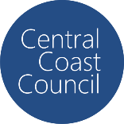
COUNCIL ASSESSMENT REPORT
HUNTER AND CENTRAL COAST REGIONAL PLANNING PANEL

PANEL REFERENCE & DA NUMBER | PPSHCC-348 – Central Coast – DA/1629/2024 – 29 St Johns Road, Jilliby, 2259
PROPOSAL | Sewage System Maintenance Works (Upgrade Existing Sewer Main)
ADDRESS | 29 St Johns Road, Jilliby (Lot 41 DP814963)
APPLICANT | SLR Consulting
OWNER | The Trust Company (Australia) Limited
DA LODGEMENT DATE | 21 November 2024
APPLICATION TYPE | Development Application
REGIONALLY SIGNIFICANT CRITERIA | Clause 5, Schedule 6 of State Environmental Planning Policy (Planning Systems) 2021: private infrastructure over $5 million
CIV | $5,635,107 (excluding GST)
CLAUSE 4.6 REQUESTS | N/A
KEY SEPP/LEP | SEPP (Planning Systems) 2021  SEPP (Biodiversity & Conservation) 2021  SEPP (Resilience and Hazards) 2021  SEPP (Transport and Infrastructure) 2021  Central Coast Local Environmental Plan 2022  Central Coast Development Control Plan 2002
TOTAL & UNIQUE SUBMISSIONS KEY ISSUES IN SUBMISSIONS | Nil
DOCUMENTS SUBMITTED FOR CONSIDERATION | Attachment A: Draft recommended conditions of consent  Attachment B: Engineering Plans  Attachment C: Statement of Environmental Effects  Attachment D: SEPP Resilience & Hazards 2021 Compliance Table  Attachment E: Aboriginal Archaeological Due Diligence Assessment
SPECIAL INFRASTRUCTURE CONTRIBUTIONS (S7.24) | N/A
RECOMMENDATION | Approval
DRAFT CONDITIONS TO APPLICANT | Yes
SCHEDULED MEETING DATE | 16 September 2025
PLAN VERSION | 27 May 2025
PREPARED BY | Jenny Tattam – Senior Development Planner
DATE OF REPORT | 28 August 2025

EXECUTIVE SUMMARY

Development application DA/1629/2024 seeks approval for sewerage system maintenance works to support the continued operation of the Twin Highway Services Centres located at 29 St Johns Road, Jilliby, and 31-35 St Johns Road, Warnervale.

The site is approximately 4.5 kilometres in length and is located between 29 St Johns Road, Jilliby in the north (the northbound service centre site) and Alison Road, Wyong in the south, within the Central Coast Council Local Government Area.

Over the past 10 years, the existing sewer system has failed several times. The purpose of the proposal is to replace the existing rising main to avoid any adverse impacts to the environment, neighbouring sites or public property.

The proposed works include the upgrade of two macerator pumps within the existing sewer pump station and installation of a new rising main. The majority of the works will occur outside the service centre site within road reserves. The consent of both Central Coast Council and Transport for NSW, as owners of the road reserves, was provided with the application.

Construction is proposed via a combination of under-boring and excavation (trenching). An arborist report was provided with the application which confirms that, subject to tree protection measures in the areas of proposed trenching, no trees are required to be removed to facilitate the proposal.

To avoid any further ground disturbance (and potential ecological impacts) the proposal includes leaving the redundant sewer rising main in the ground following construction of the new main. To avoid any collapse and possible damage to the road reserve Council’s Road Assets team have advised that the old main should be decommissioned by filling the pipe with grout. A condition has been recommended to this effect.

Being 4.5km in length the site is located within multiple zones including SP2 Infrastructure; R5 Large Lot Residential; RU1 Primary Production; C3 Environmental Management; C2 Environmental Conservation and R1 General Residential. Section 2.126 of Division 18 of State Environmental Planning Policy (Transport and Infrastructure) 2021 provides that development for the purpose of sewage reticulation systems may be carried out with consent on any land.

The proposed application is Nominated Integrated Development with the Department of Planning and Environment – Water (DPE Water) as it requires a Controlled Activity Approval under Section 91 of the Water Management Act 2000 for works within 40m of waterfront land. On 15 August 2025 DPE Water advised Council to include a condition requiring the proponent to obtain a Controlled Activity Approval prior to the commencement of works.

The application is also Integrated with WaterNSW as it requires a Water Supply Work approval under Section 90(2) of the Water Management Act 2000 for dewatering. WaterNSW issued General Terms of Approval on 27 August 2025.

Approval from Transport for NSW (TfNSW) is required under 138 of the Roads Act 1993. On 18 June 2025 TfNSW confirmed that they have no objection to the proposed development on the basis that a condition is applied requiring the proponent to complete the Form 867 Deed of Agreement for installation of a utility on a TfNSW asset (the Alison Road bridge).

Referrals to Ausgrid and Jemena were also required pursuant to State Environmental Planning Policy (Transport and Infrastructure) 2021 (‘Transport and Infrastructure SEPP’). They provided no objection to the proposal and standard conditions were received.

Internal Council referrals were also undertaken, with comments and recommended conditions considered as part of the assessment.

Jurisdictional prerequisites to the grant of consent have been satisfied including:

- Section 4.6 of the Resilience and Hazards SEPP for consideration of whether the land is contaminated;
- Section 2.48 of the Transport and Infrastructure SEPP in relation to development within 5m of an exposed overhead electricity power line; and
- Section 2.77 of the Transport and Infrastructure SEPP in relation to development adjacent to pipeline corridors.

The application was exhibited in accordance with the provisions of the Environmental Planning and Assessment Act 1979 (the Act). No submissions were received.

The application is referred to the Hunter and Central Coast Regional Planning Panel (‘the Panel’) as the development is ‘regionally significant development’, pursuant to Section 2.19(1) and Clause (5) of Schedule 6 of State Environmental Planning Policy (Planning Systems) 2021 as the proposal is private infrastructure over $5 million.

A briefing was held with the Panel on 11 March 2025 where key issues were discussed, including the need for an Aboriginal due diligence investigation, rationale for the project, construction methodology and whether the existing pipe will be decommissioned or removed. It is considered that sufficient information in relation to these matters has been provided to satisfy the issues raised by the Panel.

The potential likely impacts arising from the proposal have been assessed and include environmental impacts (trees and ecology), impacts to existing services, heritage impacts, noise and vibration, exposure of acid sulfate soils, water quality impacts from unmanaged erosion and sediment, and impacts from construction. The assessment concluded that there shall be no significant environmental impacts, and any potential impacts can be satisfactorily mitigated through a range of measures identified within the recommended conditions of consent.

Pursuant to Section 4.16(1)(a) of the EP&A Act, DA/1629/2024 is recommended for approval subject to conditions contained at Attachment A of this report.

- THE SITE AND LOCALITY

  - The Site

The application proposes sewerage system maintenance works to support the continued operation of the Twin Highway Service Centres located at 29 St Johns Road, Jilliby and 31-35 St Johns Road, Warnervale. The works involve the replacement of the rising sewer main which extends from the northbound service centre at 29 St Johns Road, Jilliby and runs 4.5km south along the road verge of Brolga Way, Hue Hue Road and Alison Road (the ‘site’ - refer to Figure 1).

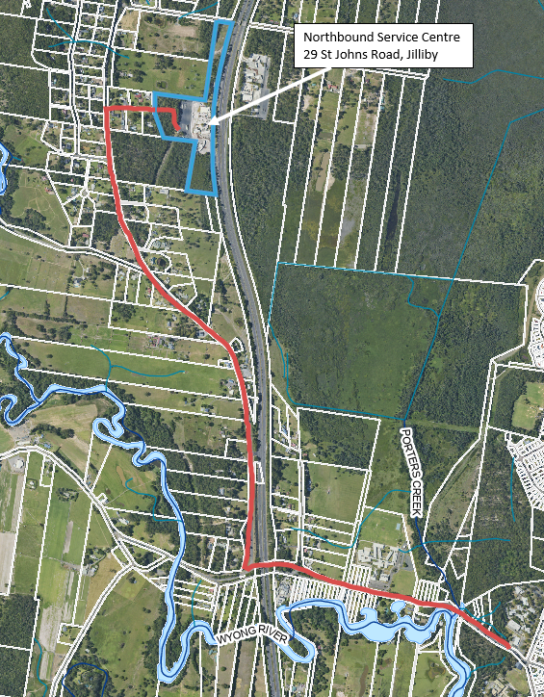
Figure 1: Aerial view of the site

29 St Johns Road, Jilliby (Lot 41 DP814963) is irregular in shape with a total area of approximately 11.5ha. This property fronts the M1 Pacific Motorway to the east and accommodates the northbound service centre which includes an Ampol service station (both truck and small vehicle fuel dispensing areas), Hungry Jacks, Oporto’s and Olivers restaurants and associated parking areas for both trucks and cars. A dense section of trees is concentrated in the western and southern undeveloped pockets of this property which help to buffer the existing development from adjoining land uses. A number of trees are located in and around the service centre complex. The proposal commences at the sewer pump station which is located in approximately the centre of 29 St Johns Road, Jilliby (refer Figure 2 below).

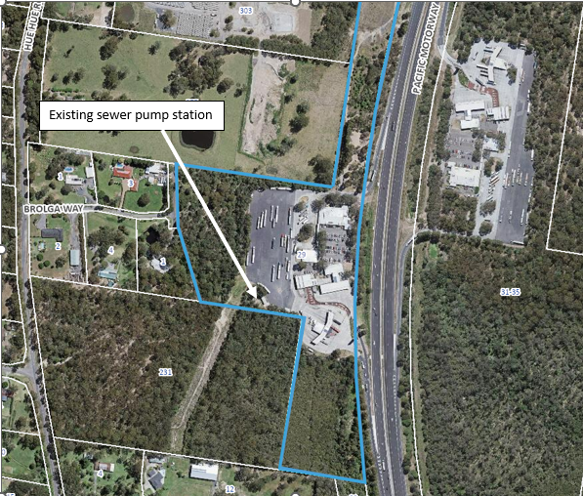
Figure 2: Closer aerial view of 29 St Johns Road, Jilliby
The majority of the works will occur outside the service centre site. The works will follow the 4.5km route of the existing rising sewer main, which traverses west from the service centre lot, along Brolga Way, south along Hue Hue Road and west along Alison Road. Works outside the site will occur solely on road reserves owned by Council or Transport for NSW (in the case of the Alison Road bridge which crosses the M1 Motorway). The works will occur within the suburbs of Jilliby, Alison and Wyong (all within the Central Coast Local Government Area). It is noted that the consent of both Council and TfNSW were provided with the application.

The site is within proximity of two mapped watercourses – the Wyong River and Porters Creek.

Parts of the site are identified as being bushfire prone land, of which approximately 50% is within the Vegetation buffer zone, and the remaining 50% is within a Vegetation Category 1 zone (refer to Figure 3).

The site is partly inundated by the 1% Annual Exceedance Probability (AEP) flood event around Wyong River/Porters Creek (refer to Figure 4).

While the majority of the site is identified as Class 5 Acid Sulfate Soils, the area around Alison Road in the south of the site is identified as Class 2-4 and Wyong Creek is identified as Class 1 (refer to Figure 5).

Parts of the site have high biodiversity value and are included within the Biodiversity Values Map as identified in ‘purple’ on Figure 6.

Two minor portions of the site intercept the Wyong Drinking Water Catchment (refer to Figure 7).

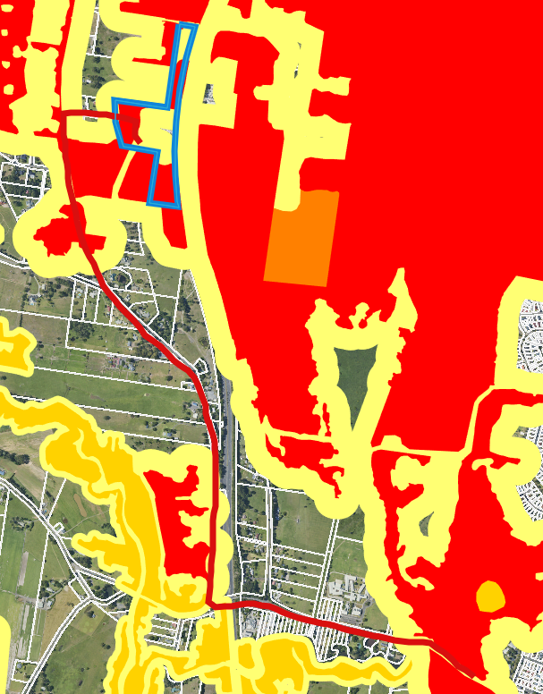
Figure 3: Bushfire prone land mapping (Source: Geogortex)

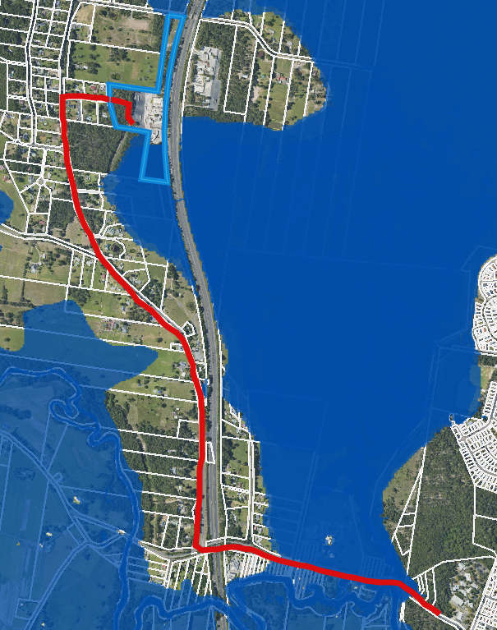
Figure 4: 1% AEP flood extent (Source: Geogortex)

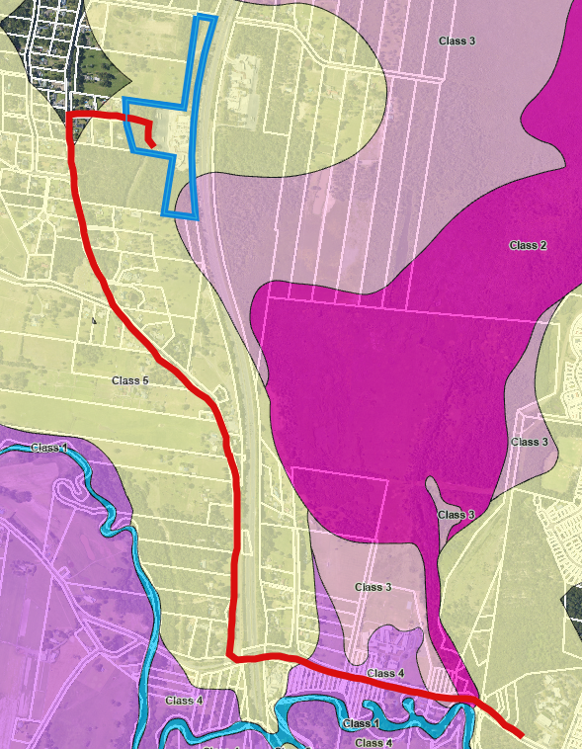
Figure 5: Acid sulfate soils map (Source: LEP)

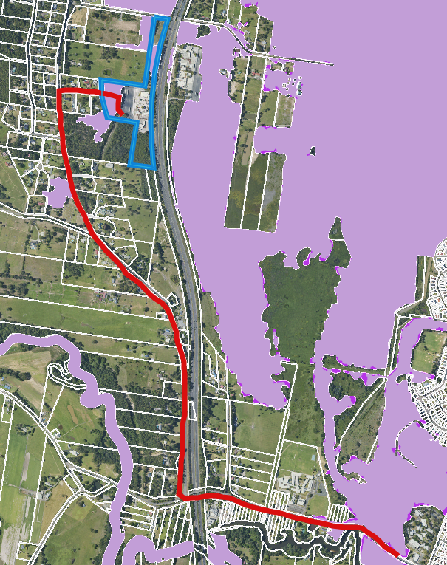
Figure 6: Biodiversity Values Map (Source: Geogortex)
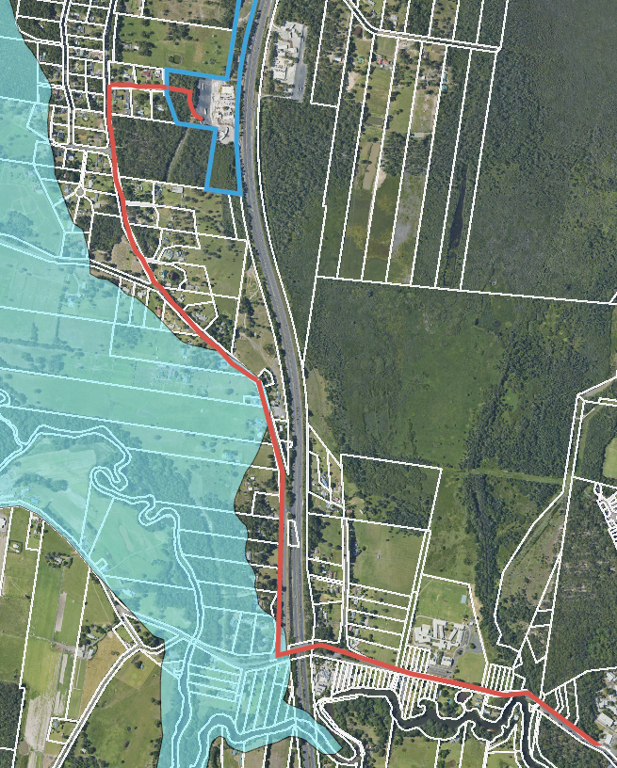
Figure 7: Drinking Water Catchment mapping (Source: Geogortex)

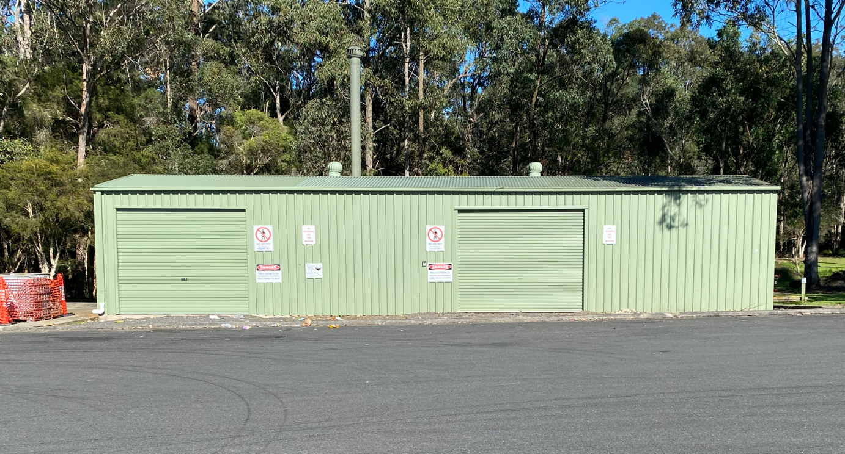
Figure 8: Existing sewer pump station at 29 St Johns Road, Jilliby
(northbound service centre site)

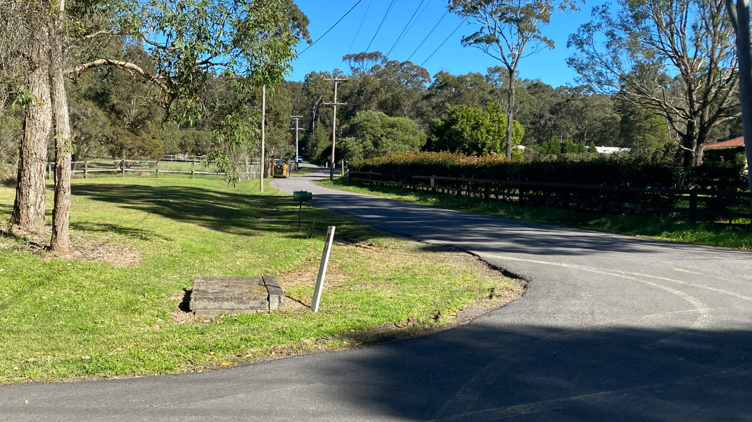
Figure 9: Looking west along Brolga Way

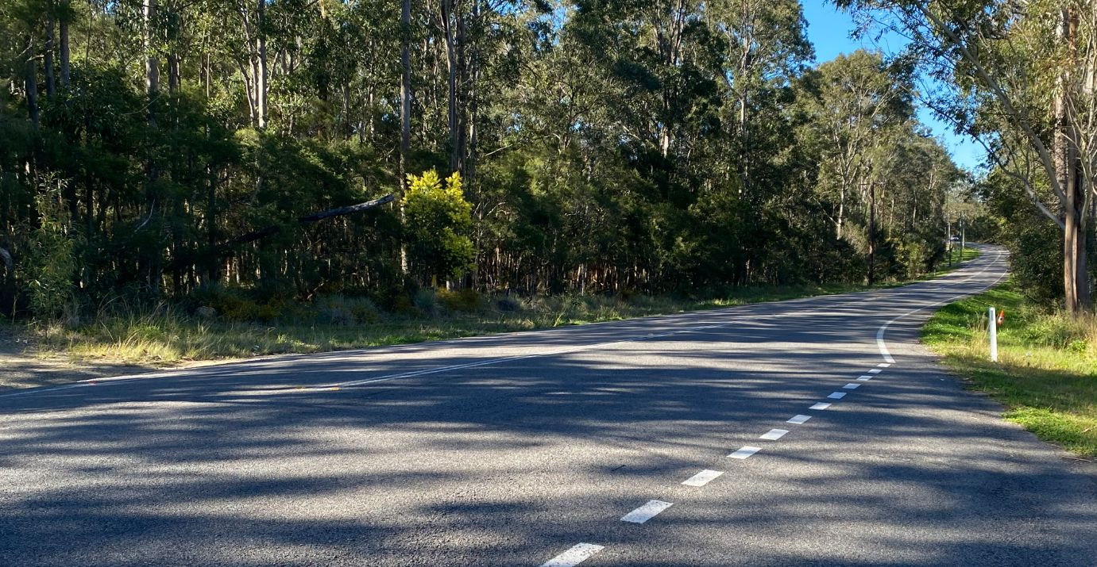
Figure 10: Road reserve within Hue Hue Road - looking south

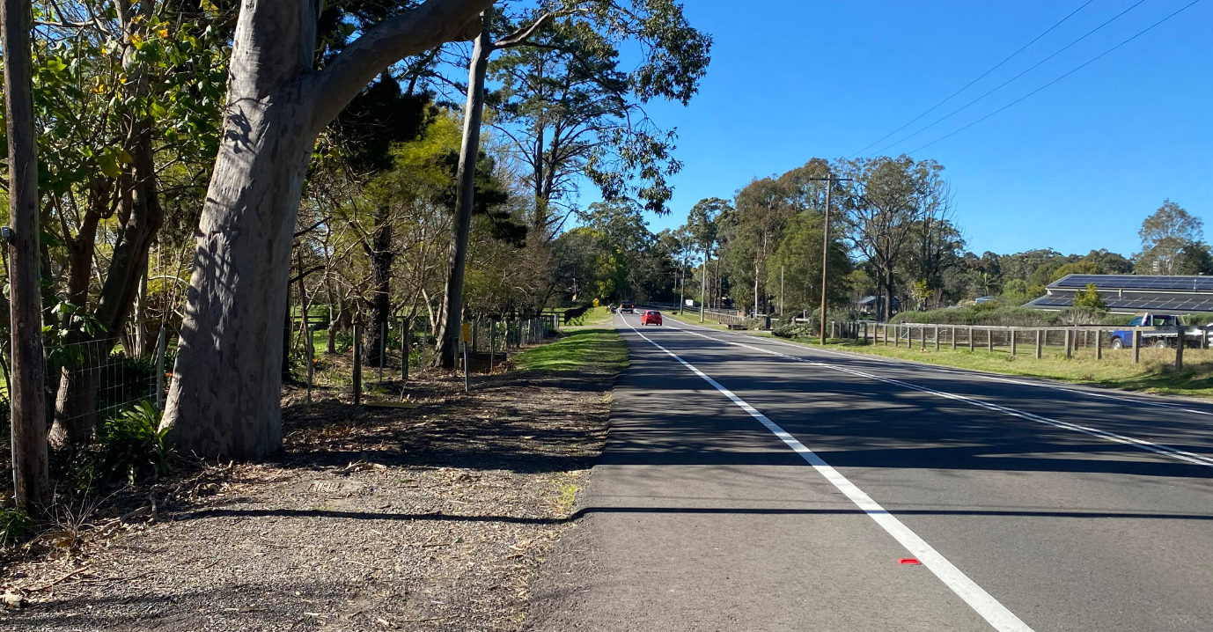
Figure 11: Road reserve within Hue Hue Road - looking further south

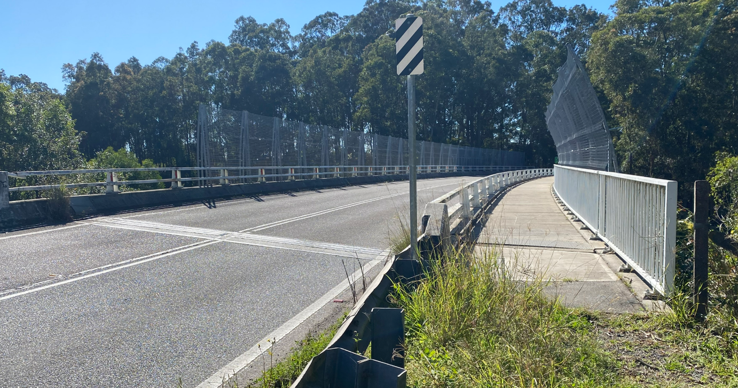
Figure 12: Alison Road bridge (which crosses over the M1 Pacific Motorway) looking east

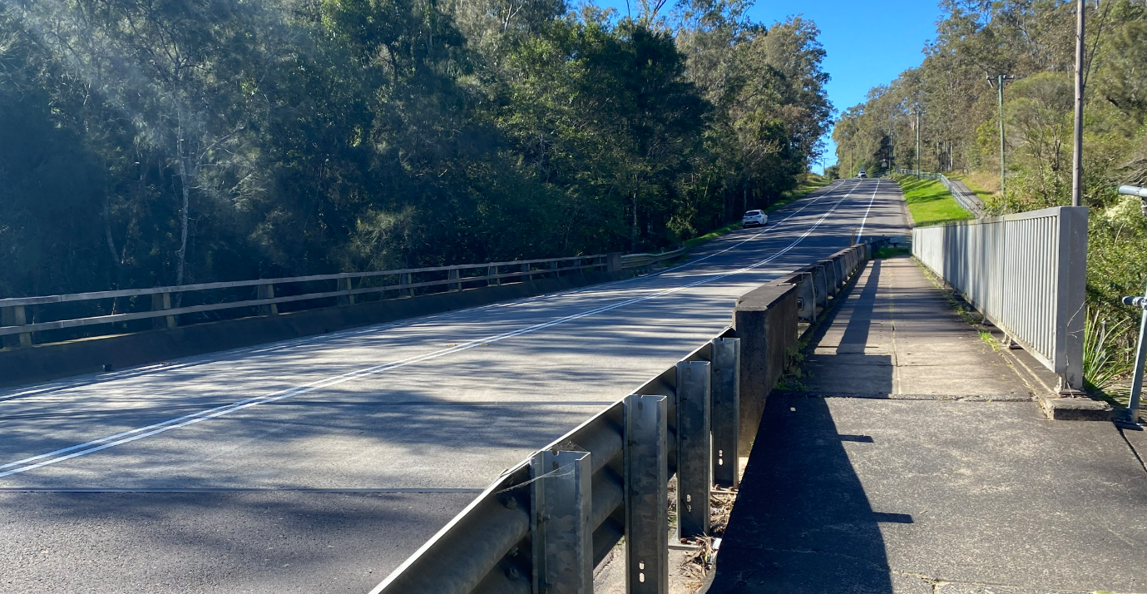
Figure 13: Porters Creek bridge looking east

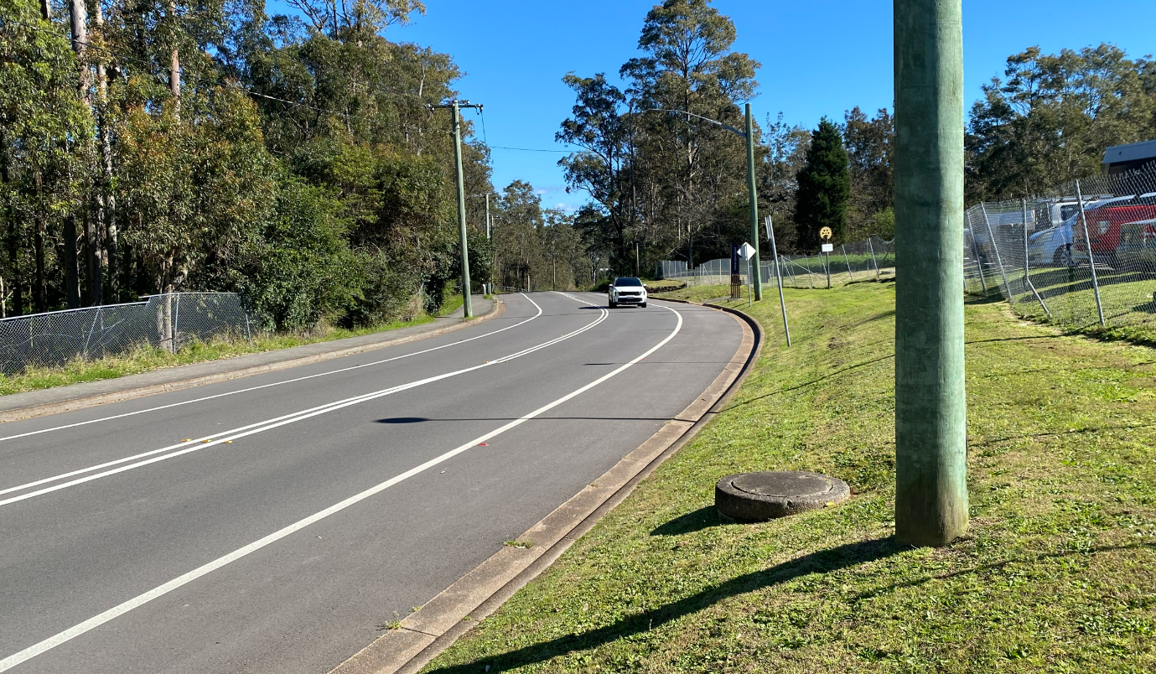
Figure 14: Approximate connection point into Council's system on Alison Road, Wyong

  - The Locality

The area along the proposed route is zoned a combination of R5 Large Lot Residential, RU1 Primary Production, C2 Environmental Conservation, C3 Environmental Management, and R1 General Residential.

Surrounding areas are diverse due to the length of the site with land uses including a mix of large lot residential, rural properties, a cemetery, commercial businesses associated with the Old Wyong Milk Factory and a school. Hue Hue Road is a major thoroughfare and provides connection between Wyong in the south and Wyee to the north.

The M1 Motorway is located to the east of the site and is not impacted by the proposal. The Alison Road bridge crosses over the M1 Motorway at the southern end of Hue Hue Road. The Alison Road bridge is owned by TfNSW.

- THE PROPOSAL AND BACKGROUND

  - The Proposal

Proposal Overview

The proposed development relates to replacement of the existing rising sewer main to support the continued operation of the Twin Highway Service Centres located at 29 St Johns Road, Jilliby and 31-35 St Johns Road, Warnervale. The route of the pipeline is approximately 4.5km in length, running westerly from the northbound service centre along Brolga Avenue, then south along Hue Hue Road to Alison Road, then east along Alison Road to the existing Council sewer manhole (CB/04) adjacent to the TAFE College in Alison Road.

Specifically, the proposal includes:

- Installation of a larger sewer rising main for the length of the route from 29 St Johns Road, Jilliby to where it terminates in Alison Road, Wyong. The new 125mm polyethylene pipe is 11mm larger than the existing PVC pipe in diameter. Polyethylene pipes are more flexible and suitable for under-boring. The new pipe follows the same route of the existing pipeline. The maximum depth of the new pipe below natural ground level shall be approximately 2.5m

- Decommissioning and removal of the existing pipeline – the two sections of existing pipeline which are located inside the Alison Road bridge and the Porters Creek bridge shall be removed to enable room for the new pipe within the bridge cavities. The remainder of the redundant pipeline is proposed to remain in situ and shall be decommissioned. The applicant has provided the following methodology for decommissioning the pipe:

  - The entire length of the old sewer line will be flushed and vacuumed using a licenced vacuum truck to remove any remaining waste or sludge.
  - All pits and chambers associated with the old line will be inspected to ensure complete evacuation of contents.
  - After cleaning, all inspection pits and redundant chambers along the old alignment will be backfilled with concrete or flowable fill to prevent subsidence or future unauthorised access.
  - End points and above-ground markers will be removed or clearly marked as decommissioned.
  - The cleaned and redundant sewer alignment will be left open and documented for potential future reuse as a conduit for services.
  - Removal – The only sections where the existing sewer main is proposed to be removed is from within the bridge cavities of the Alison Road bridge (which crosses the M1 Pacific Motorway) and the Porter’s Creek bridge.

Note: Council’s Road Assets have requested that the redundant pipeline is filled with grout. This is to remove the possibility of any collapse and damage to Council’s road reserves.

- The proposal includes replacement of the two macerator pumps within the existing sewer pump station located at the northbound service centre site.

- Approximately 0.06ha of native vegetation (grasses and shrubs) shall be removed via trenching works, and at the location of access pits enabling under-boring works to occur. However, no trees shall be impacted or removed.

- The proposal will remain as private infrastructure once it is installed and commissioned.

Construction

Installation of the new pipeline is proposed through a combination of under-boring and excavation (trench).

Trenchless Horizontal Directional Drilling (also known as ‘under-boring’) is being used to avoid areas of high biodiversity value – including two mapped areas of Biodiversity Values Land (BV Mapped) within the northern and southern portions of the proposed alignment areas. The Arborist report recommends under-boring at a minimum design depth of 0.8m below ground level, with entry and exit pits for the under-bore located outside of the Tree Protection Zone of any tree.

Installation of the pipe over the remainder of the site shall be via trenches (excavated) which may result in the removal of some shrubs and grass. The pipe will be laid in an excavated open trench which will then need to be backfilled, consolidated and the surface restored by either grass seeding or pavement restoration as appropriate.

The construction period is anticipated to be around six months.

Operation

Current sewage discharge into Council’s system is approximately 31.6kL daily. This rate is not anticipated to change once the proposed works have been finalised.

The rising main will connect into Council’s reticulated network at manhole (CB/04) in Alison Road, Wyong but will remain as private infrastructure.

Routine maintenance and inspections would be required for the infrastructure sporadically throughout the year, or as required in the instance a fault is detected.

Rationale for the project

The proposed upgrades to the rising sewer main stemming from the northbound service centre site are because of a number of failings of the system in recent years. In the past 10 years there have been a reported 25 breakages/leaks (blowouts) of the system, five of which have been in the last two years. As blowouts have occurred Ampol have repaired (patched) damaged sections of the rising main. The upgrades have been proposed to mitigate any future blowouts which may cause catastrophic environmental issues for the subject site, neighbouring sites and public property.

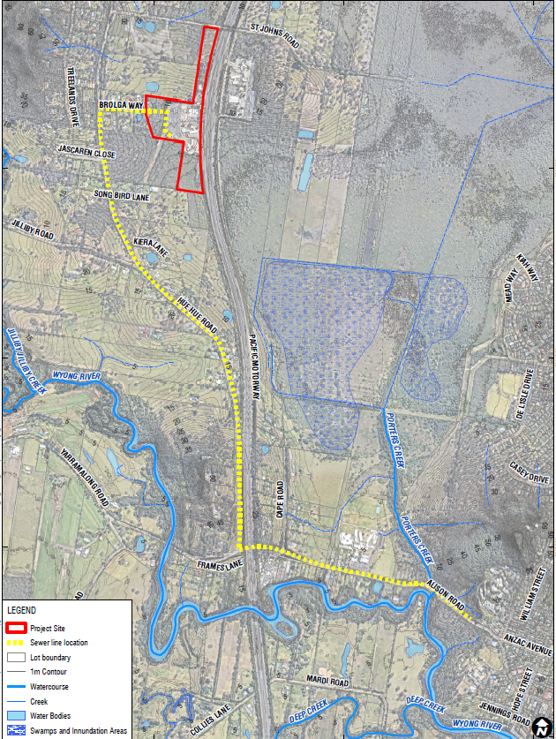

Figure 15: Proposed development

Table 1: Development Data
Control | Proposal
Site area | 4.5km (length)
GFA | N/A
Max Height | N/A – all work will be underground
Tree removal | Nil
Setbacks | All work is within the road reserves

  - Background

The development application was lodged on 21 November 2024. A chronology of the development application since lodgement is outlined below including the Panel’s involvement (briefings) with the application:

Table 2: Chronology of the DA
Date | Event
24 May 2023 | Pre-DA meeting held with Council.
21 November 2024 | Application lodged with Council.
29 November 2024 | Exhibition of the application (closed on 20 January 2025).
3 December 2024 | Ausgrid provided written concurrence.
11 December 2024 | TfNSW requested additional information.
10 January 2025 | DPE Water requested additional information.
7 March 2025 | Applicant provided a response to DPE Water RFI. Council referred the applicant’s response to DPE Water for assessment.
11 March 2025 | Panel Kick Off Briefing.
12 March 2025 | Council requested further information.
28 March 2025 | Jemena response received.
2 April 2025 | Applicant requested an extension of time to address Council RFI.
23 May 2025 | Internal Environmental Health referral comments received – RFI issued in relation to acid sulfate soils and land contamination.
28 May 2025 | Applicant provided further information.
20 June 2025 | Council’s Road Assets requested further information in regard to Porters Creek bridge crossing – RFI issued.
7 July 2025 | Council confirmed that the further information regarding Porters Creek bridge can be conditioned.
7 July 2025 | Applicant provided further information in relation to acid sulfate soils and land contamination.
27 August 2025 | Water NSW issued General Terms of Approval.

  - Site History

- Development Application No. 720/91 was approved on 20 February 1992 for Dual Freeway Service Centres.

- Development Application No. 459/1992 was approved on 27 August 1992 for Proposed Sewer Connection (to carry effluent from the Twin Service Centres to the sewer manhole in Alison Road, Wyong).

- Building Application No. 2377/1992 was approved on 1 November 1992 for Proposed Highway Service Centres.
Since the twin service stations were established in 1992, a large number of applications have been approved on the sites in relation to (amongst other things) signage, fit-outs and alterations to food premises, demolition and reconstruction of convenience store, changes to drive through lanes, shed, alterations and additions to existing parking and circulation areas, removal of trees and replacement of business identification signage and rebranding from Caltex to Ampol in 2021.

- PDA/72/2023 – a Pre-DA meeting was held on 24 May 2023 for proposed rising sewer main maintenance works.

- DA/109/2024 for Upgrade of Existing Sewer Mains was returned on 24 April 2024. The application lacked the necessary information in regard to ecology.

- DA/990/2024 for Replacement of Existing Rising Sewer Main System was rejected on 29 July 2024. The application lacked the necessary information in regard to ecology.

- STATUTORY CONSIDERATIONS

When determining a development application, the consent authority must take into consideration the matters outlined in Section 4.15(1) of the Environmental Planning and Assessment Act 1979 (‘EP&A Act’). These matters as are of relevance to the development application include the following:

- the provisions of any environmental planning instrument, proposed instrument, development control plan, planning agreement and the regulations
(i) any environmental planning instrument, and
(ii) any proposed instrument that is or has been the subject of public consultation under this Act and that has been notified to the consent authority (unless the Planning Secretary has notified the consent authority that the making of the proposed instrument has been deferred indefinitely or has not been approved), and
(iii) any development control plan, and
(iiia) any planning agreement that has been entered into under section 7.4, or any draft planning agreement that a developer has offered to enter into under section 7.4, and
(iv) the regulations (to the extent that they prescribe matters for the purposes of this paragraph),
that apply to the land to which the development application relates,
- the likely impacts of that development, including environmental impacts on both the natural and built environments, and social and economic impacts in the locality,
- the suitability of the site for the development,
- any submissions made in accordance with this Act or the regulations,
- the public interest.

These matters are further considered below.

It is noted that the proposal is (which are considered further in this report):

- Nominated Integrated Development (s4.46)
- Requiring concurrence/referral (s4.13)

Biodiversity Conservation Act 2016

The Biodiversity Conservation Act 2016 (BC Act) is the key piece of legislation in NSW relating to the protection and management of biodiversity and threatened species.

Part 6 of the BC Act relates for the Biodiversity Offsets Scheme (BOS) which provides a mechanism to avoid, minimise and offset the impacts of development and some types of clearing on biodiversity in New South Wales.

Part 7 requires a Biodiversity Development Assessment Report (BDAR) for certain developments that are likely to significantly affect threatened species. There are three threshold tests used to determine if threatened species are likely to be significantly affected, they are:

- If the development is likely to significantly affect threatened species or ecological communities or their habitats; or
- If the development exceeds the area clearing threshold; or
- It impacts vegetation on the Biodiversity Values Map.

Tests of Significance have been completed and have concluded that the proposal is unlikely to have a significant impact on species, populations and communities listed under the Biodiversity Conservation Act 2016. Seasonal surveys for threatened flora have been conducted along the route. The only threatened flora species detected was Melaleuca biconvexa, which was located outside the works footprint.

The Ecological Assessment Report (by AEP, dated 7 November 2024) states that the study area consists of the entire alignment area, which totals approximately 2.43ha, of which only 0.06ha of remnant native vegetation is expected to be removed via trenching works, and at the location of access pits enabling under-boring works to occur. The majority of the study area was determined to be disturbed road reserve vegetation, and areas with existing servicing and road infrastructure, which are subject to ongoing management and disturbance. The area threshold applies to all proposed native vegetation clearing associated with a development proposal. However, the removal of 0.06ha of native vegetation is under the 0.25ha clearing threshold that applies.

The site contains two mapped areas of Biodiversity Values Land (BV Mapped) within the northern and southern portions of the proposed alignment areas. However, all intersections within these areas will be avoided with the use of under-boring. As such impact to BV mapped land will not occur as part of this development.

In light of the above, a BDAR is not triggered and consideration of impacts on the environment is made under Section 4.15 of the EPA Act.

Roads Act 1993

Under Section 138 of the Roads Act 1993, the consent of the appropriate roads authority is required for any of the following:

(a) erect a structure or carry out a work in, on or over a public road, or
(b) dig up or disturb the surface of a public road, or
(c) remove or interfere with a structure, work or tree on a public road, or
(d) pump water into a public road from any land adjoining the road, or
(e) connect a road (whether public or private) to a classified road,

The Pacific Motorway (M1) is a classified State road and Alison Road and Hue Hue Road are local roads. Council is the roads authority for the local roads and Transport for NSW (TfNSW) is the roads authority for the M1 Pacific Motorway. The pipeline route crosses the M1 Pacific Motorway via the Alison Road Bridge which is a TfNSW asset. Accordingly, the proposal was referred to TfNSW under Section 138 of the Roads Act 1993.

TfNSW advised that further information was required in regard to the sizing of the pipeline, proposed placement and alternatives. A meeting was held between TfNSW, Council and the Applicant on 23 January 2025 to discuss TfNSW requirements.

Following the meeting the Applicant provided further information to TfNSW and on 18 June 2025 TfNSW confirmed that they have no objection to the proposed development on the basis that the following condition is included in Council’s conditions of development consent:

The Form 867 Deed of Agreement to install a utility on a TfNSW bridge is to be completed by the applicant and received by TfNSW prior to the commencement of any works.

The advice received from TfNSW has been included in the recommended conditions of consent (Condition 2.10).

Environmental Planning and Assessment Act 1979

Section 4.14 – Consultation and development consent – certain bushfire prone land

The site is identified as bushfire prone land on Council’s maps. In accordance with the provisions of Section 4.14 of the Environmental Planning and Assessment Act 1979, the consent authority is required to be satisfied that the proposal complies with the relevant requirements of Planning for Bushfire Protection 2019 (PBP), or has been provided with a certificate by a person who is recognised by the NSW Rural Fire Service as a qualified consultant in bush fire risk assessment stating that the development conforms to the relevant specifications and requirements.

The proposed development, seeking consent for the replacement of a rising sewer main, is not considered to contribute to or increase bushfire risk hazards associated with the land and in this instance, given the nature of the work, it was considered that a bushfire assessment was not required.

Furthermore, it is considered that the proposed development will not be contrary to, or hinder, the aims, objectives or principles of PBP and therefore, the Panel can be satisfied that the proposed development is consistent with the requirements of PBP and provisions of Section 4.14 of the Environmental Planning and Assessment Act 1979.

Section 4.46 – Integrated development

Section 4.46 of the EP&A Act provides that development is integrated development if in order for it to be carried out, the development requires development consent and one or more other approvals. The proposed development is classified as integrated as it requires approval under the following Acts:

Water Management Act 2000

Section 90(2) – Water Supply Work Approval

Under Section 90(2) of the Water Management Act 2000 a water supply work approval is required for any dewatering activities that intercept groundwater.

The Soil and Water Management Plan submitted with the application indicates proposed dewatering. Accordingly, the application was referred to WaterNSW under Section 90(2) for consideration as to whether a dewatering approval is required.

On 27 August 2025 WaterNSW issued their General Terms of Approval which include that the applicant should obtain a Water Supply Work approval before the commencement of any dewatering activity. WaterNSW requirements are incorporated into the conditions of consent (Condition 2.18).

Section 91 (2) – Controlled Activity Approval

The site is adjacent to two mapped waterways being Wyong River and Porters Creek. Section 91 of the Water Management Act 2000 provides that a controlled activity approval is required for any works consisting of a controlled activity that is carried out on waterfront land.

A controlled activity means:

- the erection of a building or the carrying out of a work (within the meaning of the Environmental Planning and Assessment Act 1979), or
- the removal of material (whether or not extractive material) or vegetation from land, whether by way of excavation or otherwise, or
- the deposition of material (whether or not extractive material) on land, whether by way of landfill operations or otherwise, or
- the carrying out of any other activity that affects the quantity or flow of water in a water source.

The proposal involves works on waterfront land for the installation of the pipelines. Therefore, the proposal is considered a ‘controlled activity’ and requires a ‘controlled activity approval’ under Section 91 of the Water Management Act 2000. On this basis, the development is classified as Nominated Integrated pursuant to Section 4.46 of the EP&A Act.

The application was referred to the Department of Planning and Environment-Water (DPE) who requested additional information including plans overlaid on recent aerial imagery to spatially clarify the scope of works in proximity to the mapped watercourse (Wyong River) and amended engineering plans that detail the proposed sediment and erosion control measures.

The applicant provided the further information requested by DPE. Council referred the information back to DPE for them to complete their assessment and issue General Terms of Approval (GTAs).

As of the date of writing this report DPE had not completed their assessment. On 15 August 2025 DPE (Manager CAA and IDAS) advised the following by email:

I have reviewed the additional information provided and consider the works to be very low risk for potential harm to waterfront land given that they are located entirely within the road reserve and suitable erosion and sediment controls are to be implemented throughout construction. I am comfortable for council to proceed to recommend the DA for approval without the Department's formal response.

Please ensure a condition is applied to any subsequent development consent that the proponent should obtain a controlled activity approval before works commence.

The advice received from DPE has been included in the recommended conditions of consent (Condition 2.19).

It is noted that under s4.47(5) of the EP&A Act if the approval body fails to inform the consent authority of the general terms of its approval the consent authority may determine the development application. Under s45 of the EPA Regulation 2021 an approval body has 40 days to provide written notice to the consent authority of its decision about the general terms of approval in relation to the development application. 40 days has lapsed since the further information provided by the applicant was provided to DPE-Water. It is therefore considered that the development application may be approved without receipt of DPE-Water GTAs.

Protection of the Environment Operations Act 1997

The Protection of the Environment Operations Act 1997 (POEO Act) establishes a regulatory framework for the protection and restoration of the environment. It provides a mechanism for licensing for certain activities, listed in Schedule 1 of the POEO Act. While ‘Sewage treatment’ is listed in Schedule 1, the subject application doesn’t fall within the criteria required for an EPA licence. Accordingly, referral to the EPA is not required and Council is the appropriate regulatory authority for the proposal.

  - Environmental Planning Instruments, proposed instrument, development control plan, planning agreement and the regulations

The relevant environmental planning instruments, proposed instruments, development control plans, planning agreements and the matters for consideration under the Regulation are considered below.

- Section 4.15(1)(a)(i) - Provisions of Environmental Planning Instruments

The following Environmental Planning Instruments are relevant to this application:

- State Environmental Planning Policy (Planning Systems) 2021
- State Environmental Planning Policy (Biodiversity and Conservation) 2021
- State Environmental Planning Policy (Resilience and Hazards) 2021
- State Environmental Planning Policy (Transport and Infrastructure) 2021
- Central Coast Local Environmental Plan 2022
- Central Coast Development Control Plan 2022

A summary of the key matters for consideration arising from these State Environmental Planning Policies are outlined in Table 3 and considered in more detail below.

Table 3: Summary of Applicable Environmental Planning Instruments

EPI | Matters for Consideration | Comply (Y/N)
State Environmental Planning Policy (Planning Systems) 2021 | Chapter 2: State and Regional Development  - Section 2.19(1) declares the proposal regionally significant development pursuant to Clause 5 of Schedule 6 as it comprises private infrastructure over $5 million | Yes
State Environmental Planning Policy (Biodiversity and Conservation) 2021 | Chapter 4: Koala Habitat Protection 2021  The site is not considered to be core koala habitat. The proposal is not anticipated to impact koalas. | Yes
SEPP (Resilience & Hazards) 2021 | Chapter 4: Remediation of Land  - Section 4.6 - Contamination and remediation has been considered in the Contamination Report and the proposal is satisfactory subject to conditions. | Yes
State Environmental Planning Policy (Transport and Infrastructure) 2021 | Chapter 2: Infrastructure  - Section 2.48 – Development likely to affect an electricity transmission or distribution network  - Section 2.77 – Development adjacent to pipeline corridors  - Section 2.126 – Sewage systems | Yes
Proposed Instruments | No compliance issued identified. | Yes
Central Coast Local Environmental Plan 2022 | - Clause 2.3 – Permissibility and zone objectives  - Clause 7.6 – Essential services | Yes
Central Coast Development Control Plan 2022 | - Chapter 2.14 – Site Waste Management | Yes

Consideration of the relevant SEPPs is outlined below.

State Environmental Planning Policy (Planning Systems) 2021 (‘Planning Systems SEPP’)

Chapter 2: State and Regional Development

The proposal is regionally significant development pursuant to Section 2.19(1) as it satisfies the criteria in Clause 5 of Schedule 6 of the Planning Systems SEPP as the proposal is private infrastructure over $5 million. Accordingly, the Hunter and Central Coast Regional Planning Panel is the consent authority for the application. The proposal is consistent with this Policy.

State Environmental Planning Policy (Biodiversity and Conservation) 2021

This Chapter aims to encourage the proper conservation and management of areas of natural vegetation that provide habitat for koalas to ensure a permanent free-living population over their present range and to reverse the current trend of koala population decline.

The applicant has provided an Ecological Assessment Report prepared by AEP, dated 7 November 2024 that addresses Chapter 4 of the SEPP. Several Koala use tree species are located on the site. Targeted surveys failed to identify any sign of Koala utilisation of the site. Desktop assessment of local records in the BioNet Atlas showed three Koala records within the 10km BioNet search over the past 18 years. One record from 2013 was recorded within close proximity of the site. The most recent record (2017-2019) was recorded approximately 5km south of the subject site, and the single remaining record was recorded approximately 5km north in 2007. Based on paucity of recent local records, the results of the targeted surveys as well as incidental survey work it is considered unlikely that Koalas are present within the site. Therefore, the site does not constitute Core Koala Habitat and the Panel can be satisfied that no further assessment is required.

State Environmental Planning Policy (Resilience and Hazards) 2021

Chapter 2: Coastal Management

The southern end of the site around Alison Road is located within the Coastal Environment Area and the Coastal Use Area under the SEPP (Resilience and Hazards) 2021 Chapter 2 Coastal Management.

Sections 2.10 and 2.11 provide the matters for consideration that are to be taken into account by the consent authority when determining a development application on land in a coastal environment area and coastal use area respectively. A compliance table for this SEPP has been included within Attachment D. The Panel can be satisfied the proposed development has satisfactorily addressed the matters for consideration outlined in sections 2.10 and 2.11.

In accordance with section 2.12 the proposed development is not likely to cause any increased risk of coastal hazards on the subject site or adjoining lands. And in accordance with section 2.13, there is no relevant certified coastal management program that needs to be considered.

The proposal is satisfactory in regard to Chapter 2 of the SEPP.

Chapter 4: Remediation of Land

The provisions of Chapter 4 of State Environmental Planning Policy (Resilience and Hazards) 2021 (‘the Resilience and Hazards SEPP’) have been considered in the assessment of the development application. Section 4.6 of Resilience and Hazards SEPP requires consent authorities to consider whether the land is contaminated, and if the land is contaminated, it is satisfied that the land is suitable in its contaminated state (or will be suitable, after remediation) for the purpose for which the development is proposed to be carried out. A Preliminary Site Investigation (‘PSI’) was prepared by SLR in July 2025 to assess the environmental conditions with respect to historical and current land uses which may have resulted in land contamination at the site.

Based on the review of the available site information and the proposed use of the site for a linear sewer main replacement project, the risks of contamination based on the surrounding land uses that would impact the site during the proposed sewer line development were considered to be low.

However, given the presence of the service centre (fuel facility) at the commencement of the sewer alignment and the operation of the existing sewer line, there is potential for the underlying soils and shallow groundwater to have potential for contamination. Based on the potential for contamination and the identified Acid Sulfate Soils in the site area, prior to commencement of excavation works, a Construction Environmental Management Plan (CEMP) is recommended to be created for the site to specify the worker occupational health and safety (OHS) and environmental controls related to management of excavated materials, the potential for intersection of regional groundwater, and the potential for unexpected finds – this has been recommended to be included as a condition.

The PSI also addresses waste classification of the soils in the event of off-site disposal being required. The construction layout is not finalised and based on the current proposed plan the site requires areas of filling that could utilise excavated materials on the site. Where excavated materials were not suitable for reuse or were excess to needs and not able to be reused on the wider site, then offsite disposal classification would be required. In this instance, soil sampling would be required to be completed by a suitable qualified environmental professional. With works undertaken in accordance with NSW EPA Sampling design part 1 - Application (August 2022) and classified based on criteria presented in NSW Environment Protection Authority’s Waste Classification Guideline to enable disposal in accordance with NSW EPA requirements. This could be completed prior to excavation or on stockpiled materials after the completion of the required site earthworks. A condition regarding off-site disposal has also been recommended for inclusion.

Accordingly, the Panel can be satisfied that the provisions of s.4.6 have been satisfied.

State Environmental Planning Policy (Transport and Infrastructure) 2021

The SEPP (Transport and Infrastructure) 2021 sets out the legislative requirements for certain developments that are proposed within the vicinity of critical infrastructure.
Section 2.48 – Development likely to affect an electricity transmission or distribution network

Section 2.48 of SEPP (Transport and Infrastructure) 2021 requires referral to the electricity supply authority where development is carried out within 5m of an exposed overhead electricity power line. As there are overhead electricity lines along the site the application was referred to Ausgrid. They advised via the NSW Planning Portal on 2 December 2024 that Ausgrid consents to the development subject to standard conditions which form part of the conditions of consent (Condition 1.2).

Section 2.77 – Development adjacent to pipeline corridors
Applications for development adjacent to land in a pipeline corridor are to be forwarded to the pipeline operator for review. Pipelines for gas, petroleum and other liquid fuels are relevant pipelines for the purposes of this section.

A high-pressure Trunk gas main runs through an area of the site at Alison Road, Wyong. Accordingly, the proposal was forwarded to Jemena (gas operator) who undertook a review of the proposal. They advised via the NSW Planning Portal on 27 March 2025 that prior to any construction works taking place in proximity of Jemena’s asset that the proponent must liaise with Jemena Lands team so that any proposed construction activities can be managed accordingly with Jemena engineering and field staff. Jemena’s requirements form part of the conditions of consent (Condition 2.11).

Section 2.126 – Sewage systems

In accordance with subsection 7, development for the purpose of sewage reticulation systems may be carried out with consent on any land. Accordingly, the proposal is permissible with consent.

Central Coast Local Environmental Plan 2022

The relevant local environmental plan applying to the site is the Central Coast Local Environmental Plan 2022 (‘the LEP’). The aims of the LEP include:

- to protect and promote the use and development of land for arts and cultural activity, including music and other performance arts,
  - to foster economic, environmental and social well-being so that the Central Coast continues to develop as a sustainable and prosperous place to live, work and visit,
  - to encourage a range of housing, employment, recreation and services to meet the needs of existing and future residents of the Central Coast,
  - to promote the efficient and equitable provision of public services, infrastructure and amenities,
  - to provide for a range of local and regional community facilities for recreation, culture, health and education purposes,
  - to conserve, protect and enhance the natural environment of the Central Coast, incorporating ecologically sustainable development,
  - to conserve, protect and enhance the environmental and cultural heritage of the Central Coast,
  - to minimise risk to the community in areas subject to environmental hazards, including flooding, climate change and bush fires,
  - to promote a high standard of urban design that responds appropriately to the existing or desired future character of areas,
  - to promote design principles in all development to improve the safety, accessibility, health and well-being of residents and visitors,
  - to concentrate intensive land uses and trip-generating activities in locations that are most accessible to transport and centres,
  - to encourage the development of sustainable tourism that is compatible with the surrounding environment.

The proposal is considered to be consistent with these aims, particularly a, c and e.

Zoning and Permissibility

The site is located within the following zones pursuant to Clause 2.2 of the LEP (refer to Figure 16):

- SP2 Infrastructure (Road and Traffic Facility)
- R5 Large Lot Residential
- RU1 Primary Production
- C3 Environmental Management
- C2 Environmental Conservation and
- R1 General Residential

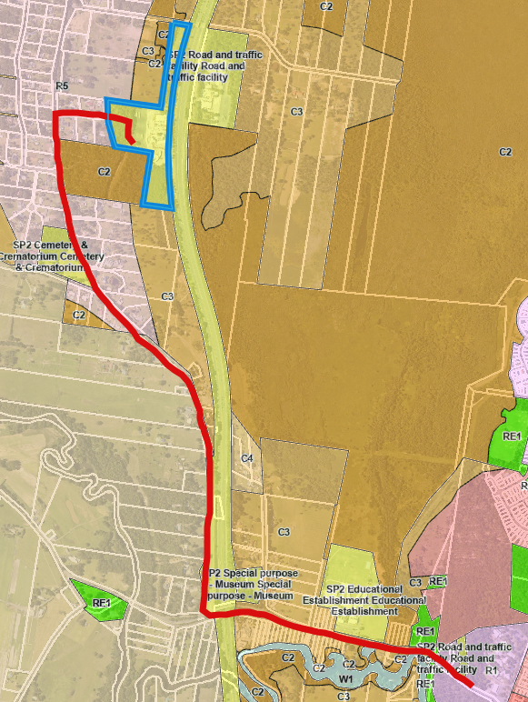

Figure 16: Zoning Map Extract (Source: LEP)
The Central Coast LEP provides the following definition for sewage reticulation system (within the group term of sewage system) which is relevant to the proposal.

sewage reticulation system means a building or place used for the collection and transfer of sewage to a sewage treatment plant or water recycling facility for treatment, or transfer of the treated waste for use or disposal, including associated—
(a) pipelines and tunnels, and
(b) pumping stations, and
(c) dosing facilities, and
(d) odour control works, and
(e) sewage overflow structures, and
(f) vent stacks.

Under CCLEP sewage reticulation systems are permitted with consent in the R5, RU1, C3, C2 and R1 zones.

Under the SP2 zone, development permitted with consent includes any development for the purpose shown on the Land Zoning Map including any development that is ordinarily incidental or ancillary to development for that purpose.

Despite the above Section 2.126 of Division 18 of State Environmental Planning Policy (Transport and Infrastructure) 2021 provides that development for the purpose of sewage reticulation systems may be carried out with consent on any land.

The objectives of the SP2 Infrastructure zone are:

- To provide for infrastructure and related uses.
- To prevent development that is not compatible with or that may detract from the provision of infrastructure.
- To recognise existing railway land, major roads and utility installations and to enable their future development and expansion.

The objectives of the R5 Large Lot Residential zone are:

- To provide residential housing in a rural setting while preserving, and minimising impacts on, environmentally sensitive locations and scenic quality.
- To ensure that large residential lots do not hinder the proper and orderly development of urban areas in the future.
- To ensure that development in the area does not unreasonably increase the demand for public services or public facilities.
- To minimise conflict between land uses within this zone and land uses within adjoining zones.

The objectives of the RU1 Primary Production zone are:

- To encourage sustainable primary industry production by maintaining and enhancing the natural resource base.
- To encourage diversity in primary industry enterprises and systems appropriate for the area.
- To minimise the fragmentation and alienation of resource lands.
- To minimise conflict between land uses within this zone and land uses within adjoining zones.
- To protect high quality and productive agricultural land, water catchment areas and land comprising high ecological or biodiversity value from inappropriate development and land management practices.
- To provide for non-agricultural land uses that support the primary production purposes of the zone.

The objectives of the C3 Environmental Management zone are:

- To protect, manage and restore areas with special ecological, scientific, cultural or aesthetic values.
- To provide for a limited range of development that does not have an adverse effect on those values.
- To provide a buffer to land of high ecological value or land that has environmental constraints or hazards.

The objectives of the C2 Environmental Conservation zone are:

- To protect, manage and restore areas of high ecological, scientific, cultural or aesthetic values.
- To prevent development that could destroy, damage or otherwise have an adverse effect on those values.

The objectives of the R1 General Residential zone are:

- To provide for the housing needs of the community.
- To provide for a variety of housing types and densities.
- To enable other land uses that provide facilities or services to meet the day to day needs of residents.
- To promote best practice in the design of multi dwelling housing and other similar types of development.
- To ensure that non-residential uses do not adversely affect residential amenity or place unreasonable demands on services.

The proposal is consistent with the above zone objectives for the following reasons:

- It will deliver much needed infrastructure to support the existing Twin Highway Service Centres.
- The proposal will not result in any land use conflicts.
- The development is an appropriate development within the road reserves.
- The proposal is not anticipated to adversely impact the ecological, scientific, cultural or aesthetic values of the area.

General Controls and Development Standards (Part 2, 4, 5 and 6)

The LEP also contains controls relating to development standards, miscellaneous provisions and local provisions. The controls relevant to the proposal are considered in Table 4 below.

Table 4: Consideration of the LEP Controls
Control | Requirement | Proposal | Comply
Demolition requires development consent  (Cl 2.7) | The demolition of a building or work may be carried out only with development consent. | The proposal includes demolition of the existing sewer rising main within the two bridge cavities of Alison Road bridge and Porters Creek bridge. Details have been provided. | Yes
Heritage  (Cl 5.10) | Objective of this clause is to protect the heritage of the Central Coast. | The following LEP listed heritage items are adjacent to the sewer rising main:  - Jilliby Cemetery 15 Jilliby Road, Corner Hue Hue Road Lot 7005, DP 1030922 Local I71  - Former Wyong Dairy Co-Operative 141–155 Alison Road Lot 100, DP 1181923 Local I371  - Alison Homestead 1 Cape Road Lot 51, DP 788246 Local I375  However, no works are proposed within the curtilage of heritage items or heritage conservation areas. The proposed works have been assessed by Council’s Heritage Officer and they have advised that the proposal will not adversely impact the cultural or built heritage values of the sites or their settings. The development application is acceptable from a European heritage perspective.  The Applicant has provided an Aboriginal Archaeological Due Diligence Assessment (prepared by Virtus Heritage, dated 27/05/2025). Following the requirements of the Due Diligence Code, the desktop assessment and visual inspection found no known Aboriginal objects in the project area and concluded that there was a low probability to encounter unknown Aboriginal objects through the majority of the inspected areas. However, the section of project area located on the bank of the Wyong River is in a sensitive landform. Accordingly, the report recommended the implementation of an Unexpected Find Procedure and Unexpected Human Remains Procedure and Induction of site workers. These requirements are incorporated into the conditions of consent. | Yes
Flood Planning  (Cl 5.21) | Objectives of this clause are to minimise the flood risk to life and property and to avoid significant adverse impacts on flood behaviour and the environment. | Part of the site around Wyong River is flood prone land. However, given the pipeline will be located under the ground there shall be no flood impacts, no risk to life and no specific requirements. | Yes
Acid Sulfate Soils  (Cl 7.1) | The objective of this clause is to ensure development does not disturb, expose or drain acid sulfate soils and cause environmental damage. | While the majority of the proposed works will occur on land mapped as Class 5 acid sulfate soils (where the occurrence of acid sulfate soils is typically low) the presence of adjacent Class 1–4 areas (particularly near Alison Road and Wyong Creek) introduce several potential pathways for acid sulfate soils disturbance during construction. In accordance with Clause 7.1 the applicant was requested to provide an acid sulfate soils management plan (ASSMP). Council’s Environmental Health Officer has reviewed the submitted ASSMP and found it acceptable subject to conditions. | Yes
Drinking Water Catchments  (Cl 7.2) | The objective of this clause is to protect drinking water catchments by minimising the adverse impacts of development on the quality and quantity of water entering drinking water storages. | The site intercepts a Drinking Water Catchment in two locations. Clause 7.2 provides that the consent authority must consider whether or not the development is likely to have an adverse impact on the quality and quantity of water entering the drinking water storage. There are no waterways within the proposal footprint that drain into the drinking water catchment. Suitable erosion and sediment control measures shall be implemented prior and during construction. A Controlled Activity Approval from DPE-Water is required prior to works commencing on ‘water front’ land, and a Water Supply Work Approval is required from Water NSW. Further, a condition of consent requires an Emergency Response Management Plan prior to commencement of any works which will identify measures to deal with any issues (eg leaks) with the pipeline. The proposal is not considered to have an adverse impact on the drinking water catchment. | Yes
Essential Services  (Cl 7.6) | This Clause requires Council to ensure that services such as water, sewer, electricity, stormwater drainage, vehicular access and waste management can be adequately provided. | The proposed works will not impact existing essential services and will not require the enhancement of existing services. The works aim to improve existing sewerage services, thus will provide an upgraded service to the subject site and surrounds. | Yes

The proposal is generally consistent with the LEP.

- Section 4.15 (1)(a)(ii) - Provisions of any Proposed Instruments

N/A
- Section 4.15(1)(a)(iii) - Provisions of any Development Control Plan

The following Development Control Plan is relevant to this application:

- Central Coast Development Control Plan 2022 (‘the DCP’)

Chapter 2.14 - Site Waste Management

A Waste Management Plan (WMP) was submitted with the application. It confirms that very little waste will be generated by the construction activities. Council’s Waste Control Officer reviewed the WMP and advised that as the proposal will not generate any ongoing waste specific conditions are not required.

Chapter 5.36 – Warnervale M1 Pacific Motorway Service Centres

This Chapter provides the development concepts, standards and design requirements for the service centres located on the M1 Pacific Motorway.

It includes design guidelines for new built development, signage, landscaping and lighting which are not relevant to the subject proposal.

Relevant provisions require that the two service centres are operated as an integrated complex and development should not harm Melaleuca bioconvexa (threatened species), endangered ecological community swamp sclerophyll forest, wetlands or other environmentally sensitive land.

The proposal is to replace the existing sewer rising main that services both the northbound and southbound service centres that operate as an integrated complex by Ampol.

Seasonal surveys for threatened flora have been conducted along the route. The only threatened flora species detected was Melaleuca biconvexa, which was located outside the works footprint. There shall be no impacts to any areas of swamp sclerophyll forest. There are no wetlands within proximity of the site and impacts to land mapped on the Biodiversity Values map (BV mapped) is being avoided using under-boring in these areas.

The proposal is satisfactory with regard to Chapter 5.36.

- Central Coast Council Section 7.11 & 7.12 Contribution Plans

There are no contributions applying to the proposed upgrade works under Council’s Section 7.11 Plan for the Wyong District.

The proposed upgrade works are not considered to result in an intensification or addition to the existing development, therefore, there are no contributions required under Council’s Section 7.12 Plan.

- Housing Productivity Contribution

The Housing Productivity Contribution (HPC) is not applicable to the development.

- Water and Sewer Contributions

Water and sewer contributions are applicable and will be levied as part of the Section 306 requirements under the Water Management Act 2000.

- Section 4.15(1)(a)(iiia) – Planning agreements under Section 7.4 of the EP&A Act

There have been no planning agreements entered into and there are no draft planning agreements being proposed for the site.

- Section 4.15(1)(a)(iv) - Provisions of Regulations

In accordance with Section 66A of the Environmental Planning and Assessment Regulation 2021 (the Regulation) Council related development applications must not be determined by the consent authority unless: the council has adopted a conflict-of-interest policy; and the council considers the policy in determining the application. Accordingly, the subject application is not a Council related development application and Section 66A of the Regulation does not apply.

In accordance with Section 23 of the Regulation the Panel can be satisfied that the correct landowner’s consent has been submitted for the development application. In accordance with Section 24 the Panel can be satisfied that the development application is on the approved form and contains all the information and necessary documents required by the approved form, and the EP&A Act and Regulation in accordance with Section 24(1)(a) and (b).

  - Section 4.15(1)(b) - Likely Impacts of Development

The likely impacts of that development, including environmental impacts on both the natural and built environments, and social and economic impacts in the locality must be considered. In this regard, potential impacts related to the proposal have been considered in response to SEPPs, LEP and DCP controls outlined above and the Key Issues section below.

The consideration of impacts on the natural and built environments includes the following:

- Trees – the application is supported by an Arborist Impact Assessment (AEP, dated 07/11/2024). A total of 211 trees and two stands identified within the site and neighbouring properties were assessed. 171 trees are native species and 41 are non-native. The Tree Protection Zone (TPZ) and Structural Root Zone (SRZ) are indicative areas critical for maintaining a tree’s viability and stability respectively, holding the majority of the roots necessary for each function. Any ground works within these zones is likely to impact the viability or stability of the tree by injuring the root system. A potential impact assessment was made for each assessed tree:

  - The SRZ of 16 trees may be encroachment by the proposed trenching works.
  - The TPZ of 12 trees may have major encroachment by the proposed trenching works.

These trees can only be retained if the following construction methods are undertaken:

  - Ground protection measures in accordance with Australian Standard AS 4970-2009 Protection of trees on development sites;
  - The use of “soft” construction methods including manual and vacuum removal of soils; and
  - Works within the SRZ/TPZ should be conducted under supervision of the project arborist.

An additional 38 trees have the potential for minimal impacts from trenching, being a sufficient distance away from the development footprint to be retained without specific tree protection measures. General tree protection measures are recommended for these trees.

145 trees will have minimal impacts using under-boring. The Arborist report recommends under-boring by directional drilling at a minimum design depth of 0.8m below ground level, with entry and exit pits for the under-bore located outside of the TPZ.

Council’s Arborist has reviewed the proposal and is satisfied that all trees can be retained in accordance with the recommendations in the Arborist Report. Construction works must be undertaken under the direct supervision of an AQF5 Project Arborist. Conditions have been recommended.

- Ecology – The proposed route intersects two areas of vegetation included on the NSW Biodiversity Values Map. The areas of mapped vegetation are at the start of the route near the service station, and the end near Wyong River. If clearing is proposed within a mapped area, it usually triggers the need for a Biodiversity Development Assessment Report (BDAR). However, through the use of under-boring in these mapped areas, clearing of vegetation is not proposed and a BDAR is not triggered.

To further avoid surface disturbance, it is proposed to retain the old pipelines in the ground. Councils Water & Sewer and Road Assets have confirmed they have no objection to the redundant pipes staying in the ground, subject to appropriate decommissioning procedures

While approximately 0.06 ha of native vegetation (grass and shrubs) shall be impacted by the proposal no trees shall be removed or adversely impacted.

Seasonal surveys for threatened flora have been conducted along the route. The only threatened flora species detected was Melaleuca biconvexa, which was located outside the works footprint. No threatened fauna species were recorded within the site.

Tests of Significance ('5 part tests') have been completed to meet the requirements of Section 7.3 of the Biodiversity Conservation Act 2016 (BC Act), and concluded that the proposal is unlikely to have a significant impact on species, populations and communities listed under the Biodiversity Conservation Act 2016.

Based on the information provided and internal assessment, the proposed development, subject to compliance with the recommended conditions, will not likely result in significant adverse impacts upon the natural environments. However, if post consent there is any additional vegetation or tree removal outside the assessed area or removal of vegetation within a BV mapped area, due to changed engineering requirements at detailed design stage, further assessment (and potentially a BDAR) would be required. A condition has been recommended which requires a copy of the detailed engineering plans and an accompanying letter from the Project Ecologist confirming that the proposal will not result in any tree or vegetation impacts outside that already assessed within the Ecology and Arborist reports (Condition 2.2).

- Impact on existing utility services – the proposed new sewer rising main is to be laid within road reserves that have existing services, including - the existing sewer rising main, Council’s water main, gas main, telecommunications and electricity.

The engineering plans submitted with the application identify services within the road reserve horizontally but not vertically. The applicant was asked to confirm separation requirements to other services, and these have been indicated on the proposed plans.

Prior to construction, a service detection provider will need to be engaged to accurately locate the other services and confirm their vertical alignment to ensure adequate separation is achieved.

Council queried what will happen if there is a conflict between the old and new rising mains at the same vertical alignment e.g., around the culvert crossing in Brolga Way and pit locations etc. The applicant has advised that if minor conflicts arise—such as at culverts or pits—these are addressed through vertical offsetting or design refinement without requiring removal of the existing asset. Using the Horizontal Directional Drilling (HDD) methodology, the vertical offsetting can be achieved with no impacts and negates the need to expose existing in ground services which reduces risk of damage to other service providers and public and private property. In any location where HDD is not possible, the least impactful excavation, such as Non-Destructive-Excavation (sucker trucks) will be utilised so that the environmental and ecological impacts are manageable and that detailed plans will be developed prior to construction.

If detailed plans indicate that proposed under-boring cannot be achieved and that the proposal may result in impacts that have not been assessed in the Ecological Impact Assessment Report and/or Arborist Report additional assessment may be required. Therefore, Condition 2.2 has been recommended requiring a copy of the detailed engineering plans and letter from the Project Arborist prior to commencement of works confirm there shall be no further tree/vegetation impact to that already assessed.

As well as the existing services within the road reserves that have been identified on the applicant’s submitted plans, along the Alison Road portion of the route, there is an existing sewer rising main for the Wyong Milk Factory and another for the nearby Wyong Christian Community School. Both rising mains connect to the Council system at manhole as the subject main (CB/04). A condition of consent requires that this infrastructure is physically located prior to commencement of works to ensure that the proposed design does not conflict with these existing private mains.

Ausgrid has provided comment given the location of overhead power lines along the site and provided standard conditions. Jemena requested the proponent liaise with the Jemena Lands Team prior to works commencing so that the works to be managed with Jemena engineering and field staff. These requirements are incorporated into the recommended conditions.

Engineering have agreed that the design concept is viable. Given that this is private infrastructure, the developer will be responsible for ensuring that the proposal will not result in any adverse impacts to other services.

- Aboriginal due diligence – the applicant provided an ‘Aboriginal Archaeological Due Diligence Assessment’ prepared by Virtus Heritage, dated 27 May 2025. The report was prepared in accordance with Due Diligence Code of Practice for the Protection of Aboriginal Objects in New South Wales and included consultation with relevant Aboriginal stakeholder groups including the Darkinjung Local Aboriginal Land Council.

The southern part of the project area that runs along Alison Road is in a sensitive landform under the Due Diligence Code (within 200m of waters). Under the Code, it is recognised that these areas may have increased potential for Aboriginal objects ‘as a result of Aboriginal people’s use of those features in their everyday lives and for traditional cultural activities’.

Preparation of the report included review of existing heritage registers and database searches, previous archaeological research and discussions. An extensive AHIMS search was undertaken which did not identify any recorded sites within the project area.

The report considered the potential for Aboriginal objects and places to occur within the project area. Previous surveys of Hue Hue Road suggest there is limited potential for cultural material due to extensive agricultural use and infrastructure development. The section of the project area along Alison Road has greater potential due to its proximity to the Wyong River, the presence of wooded areas at its eastern end, and the proximity to a registered scar tree located approximately 300m south of Alison Road.

A site inspection was undertaken to assess any potential Aboriginal archaeological sites and/or cultural heritage constraints in the project area. No Aboriginal objects or places were identified in the project area during the site inspection.

In conclusion the potential of subsurface artefacts is assessed as low, however the section of the project area located on the bank of the Wyong River is in a sensitive area. The report included three recommendations – implementation of an unexpected find procedure and unexpected human remains procedure and workers induction. Conditions have been recommended (Conditions 2.17, 3.16 & 3.18).

- Noise and vibration – SLR Consulting Australia conducted a noise impact assessment in December 2023. Nearest noise sensitive receivers were identified along the entire route, and the existing noise environment was defined using unattended noise monitoring (Nov 2023) to set the criteria used to assess the potential noise impacts in accordance with the NSW Interim Construction Noise Guideline (ICNG). The impacts during construction of the project were predicted to be typical of construction works near to sensitive receivers. No works outside of standard construction hours are currently proposed.

Construction noise impacts were predicted to vary between negligible and very high impact, depending on the location of works along the sewer line. Reasonable and feasible construction noise measures have been recommended as well as additional mitigation practices for residences likely to experience moderate to very high impacts including notification, noise verification, phone call notifications and project specific respite offers – the inclusion of noise mitigation measures in the CEMP has been conditioned.

Vibration levels from construction and operation of the project are predicted to be significantly below the relevant criteria for cosmetic damage criteria, human comfort and human perception at all receivers. Reasonable and feasible vibration measures during construction have been recommended which have also been conditioned.

Predicted increases in road traffic noise during construction on the surrounding road network are predicted comply with the NSW Road Noise Policy.

Conditions are included requiring compliance with the mitigation measures in the noise and vibration impact assessment (Conditions 2.5 & 3.10).

- Erosion and sediment controls – the application was supported by a Soil and Water Management Plan (SWMP) prepared by SLR Consulting. The purpose of the SWMP is to prevent adverse impacts on the surrounding water quality and prevent pollution of the downslope environment during construction works. The SWMP states that a series of site-specific Erosion Sediment Control Plans (ESCPs) will be prepared as part of the Construction Environmental Management Plan (CEMP) that is required to be approved by Council prior to commencement of works (Condition 2.5). The SWMP outlines mitigation measures and site management practices including clean water diversion channels, sediment fences and monitoring.

As part their request for further information DPE-Water requested amended engineering plans that depict the soil and water management controls outlined in the SWMP prepared by SLR Consulting. These amended plans were prepared by the Applicant and provided to DEP-Water who have advised that the proposed erosion and sediment control measures are suitable to avoid any potential harm to waterfront land.

The SWMP also details proposed dewatering which will include water quality monitoring. Water that meets the discharge water criteria can then be discharged from site into the adjacent stormwater system. Water that does not meet the discharge water quality requirements will be contained on-site and treated further prior to additional testing or trucked offsite. A dewatering licence (work approval) from Water NSW is required prior to the commencement of any dewatering on site.

- Acid sulfate soils - consideration has been given to the likelihood that acid sulfate soils would be disturbed, exposed or drained and cause environmental damage as a result of the proposed development.

SLR Consulting prepared a Preliminary Acid Sulfate Soil Management Plan (ASSMP) in July 2025 to minimise the risk of adverse effects of exposing ASS to the environment. Although much of the proposed alignment lies within Class 5 ASS zones (where the occurrence of ASS is typically low) the presence of adjacent Class 1–4 areas (particularly near Alison Road and Wyong Creek) introduce several potential pathways for ASS disturbance during construction. These risks are consistent with exposure mechanisms outlined in Acid Sulfate Soil Assessment Guidelines by Adhern et al. (1998) and Acid Sulfate Soils Manual by Stone et al. (1998), which identify oxidation, exposure, and poor spoil handling as primary triggers for acid generation in construction settings. The proposed use of directional drilling significantly reduces direct disturbance however, it does not eliminate ASS risk particularly from associated excavation zones and dewatering. As such, proactive monitoring and contingency measures would be critical in preventing acid generation where ASS soils are intersected.

Where the proposed sewer alignment traverses through or in the vicinity of an identified Class 2 – 4 ASS areas, a program of targeted field sampling should be completed to assess the soil conditions prior to excavation. The implementation of the ASSMP has been conditioned.

- Sewer pump station – the subject sewer rising main services both the southbound and northbound service centres. The southbound site has a sewer pump station which takes wastewater from this site under the M1 Motorway to a sewer pump station located on the northbound site. The wastewater is then combined with the wastewater from the northbound service centre before being discharged through the sewer rising main.

Historically Council did not require private sewer pump stations to have an Approval to Operate under section 68 of the Local Government Act 1993 (LG Act). The site has however, always operated under a Trade Waste Approval.

In 2020/21 Council conducted an audit of the local government area to identify private sewer pump stations to require compliance with Section 68 of the LG Act. However, no applications were received for the site. Accordingly, there are no current Approvals to Operate in place for either of the existing sewer pump stations.

Council recently wrote to Ampol and requested them to apply for an Approval to Operate the sewer pump stations. An application has now been received in relation to this requirement.

Council’s Environmental Health Officer has advised that Approvals to Operate the sewer pump stations will be issued following finalisation of the subject development application. This is because the subject proposal includes alterations to the northbound sewer pump station, in the form of replacement of the two macerator pumps, which requires a specific ‘Approval to Alter’ under s68 of the LG Act (Condition 2.16). This approval will include conditions that will need to be complied with before an Approval to Operate can be issued. Following construction works but prior to operating the system a further condition requires that an Approval to Operate is obtained (Condition 4.2).

- Public Domain – While proposed trenching may impact some driveways – any disturbance will be within the road reserve owned by Council. Conditions have been included requiring submission of a dilapidation report to Council that covers road, kerb, gutter, footpath, driveways, street trees, street signs, street-lights or any other Council assets in the vicinity of the development. Upon completion of works any damage to Council’s infrastructure will need to be repaired by the developer.

A condition has also been included for revegetation of disturbed areas within the road reserves with native species (Condition 3.8).

- Construction – construction activities include stripping of vegetation, subsoil and topsoil, demolition (of the existing sewer rising main within two bridges), establishment of infrastructure, vehicle and machinery movements, excavation dewatering activities and landscaping. To mitigate and manage potential environmental impacts from construction activities conditions have been recommended requiring the following further information prior to the commencement of works:

  - A Construction Environmental Management Plan (CEMP) that brings together the mitigation and management measures in relation to acid sulfate soils, noise and vibration, land contamination and erosion and sediment control.
  - The CEMP also needs to detail how sewage will be managed from the Twin Service Centres when the existing rising main is offline and associated environmental mitigation and management measures.
  - A Construction Traffic and Pedestrian Management Plan (CTPMP) that details traffic management including access and manoeuvring, control of pedestrian and vehicular traffic, deliveries and stockpile locations.

Any interruptions to local pedestrian or vehicle traffic will require a Road Occupancy Licence, and a Road Opening Permit will also be required prior to the commencement of works within the road reserve.

It is considered that the appropriate conditions are recommended to mitigate against potential impacts during construction.

- Social and economic impacts – impacts related to the construction of the proposal would be temporary and largely localised to the construction area. The Acoustic report recommends receivers located along the alignment of the new rising main are notified in writing of upcoming construction works. Construction of the proposal would result in short-term impacts (eg, noise, traffic and access) that have been addressed in the application or will be by the further approvals required by Council prior to construction commencing (eg, CEMP and Construction Traffic and Pedestrian Management Plan).

Implementation of the proposal will support the continued operation of the M1 Twin Service Centres. Positive employment impacts will result from the construction and ongoing operation of the proposal.

Accordingly, it is considered that the proposal will not result in any significant adverse impacts in the locality as outlined above.

  - Section 4.15(1)(c) - Suitability of the site

In regard to natural hazards the site is identified as bushfire prone land and bushfire management has been satisfactorily addressed in the application. No specific conditions are required.

Given the land zoning and minimisation of impacts on adjoining land uses, the site is suitable for the development.

  - Section 4.15(1)(d) - Public Submissions

N/A – no public submissions were received.

  - Section 4.15(1)(e) - Public interest

The proposed development is permissible within the various land use zones that apply to the land and is not expected to adversely impact upon the amenity of the locality or the surrounding environment. The proposal is to undertake urgent upgrades to much needed infrastructure to support the ongoing operation of the Twin Highway Service Centres. Approval of the application is in the public interest.

- REFERRALS AND SUBMISSIONS

  - Agency Referrals and Concurrence

The development application has been referred to various agencies for comment/concurrence/referral as required by the EP&A Act and outlined below in Table 5.

There are no outstanding issues arising from these concurrence and referral requirements subject to the imposition of the recommended conditions of consent being imposed.

Table 5: Concurrence and Referrals to agencies
Agency | Concurrence/  referral trigger | Comments  (Issue, resolution, conditions) | Resolved
Concurrence Requirements (s4.13 of EP&A Act) – N/A
Referral/Consultation Agencies
Electricity supply authority | Section 2.48 – State Environmental Planning Policy (Transport and Infrastructure) 2021  Development near electrical infrastructure | The proposal includes development within 5m of an exposed overhead electricity power line. By their letter dated 2 December 2024 Ausgrid provided consent to the development subject to conditions. | Yes
Jemena (gas authority) | Section 2.77 – State Environmental Planning Policy (Transport and Infrastructure) 2021  Development adjacent to pipeline corridors | The proposal is within vicinity of a gas pipeline. By their letter dated 27 March 2025 Jemena raised no objection to the proposal subject to conditions. | Yes
Integrated Development (S 4.46 of the EP&A Act)
Water NSW | Section 90(2) of the Water Management Act 2000  Water Supply Work Approval (dewatering) | Under Section 90(2) of the Water Management Act 2000 an approval from WaterNSW is required for any dewatering. The application was referred to WaterNSW who issued General Terms of Approval on 27 August 2025. | Yes
Department of Planning & Environment – Water | Section 91 of the Water Management Act 2000  Controlled Activity Approval | The proposal involves works on waterfront land and requires a Controlled Activity Approval from DPE-Water. The application was referred to DPE-Water who requested additional information from the applicant. This information was provided and on 15 August 2025 DPE-Water advised that the proposed works are considered to be very low risk because they are located entirely within the road reserve and suitable erosion and sediment controls are proposed. They advised Council to proceed with approval of the proposed development without DPE-Water’s formal response subject to a condition requiring the proponent to obtain a Controlled Activity Approval prior to commencement of any works. | Yes

  - Council Officer Referrals

The development application has been referred to various Council officers for technical review as outlined Table 6.

Table 6: Consideration of Council Referrals
Officer | Comments | Resolved
Water and Sewer | Water and sewer reviewed the proposal and requested further information to confirm the discharge rate into Council’s sewer system. Further information was provided, and Water and Sewer advised there are no objections to the proposal subject to conditions. | Yes
Engineering | Council’s Engineering Officer reviewed the proposal and raised several questions which were included in the RFI letter, and which have since been resolved. The Engineering Officer has provided updated comments and raised no objection subject to conditions. | Yes
Road Assets | Road Assets are responsible for the road reserves owned by Council. They reviewed the proposal and requested that the main was moved as far west as possible at the intersection of Hue Hue Road and Alison Road to provide for future potential upgrades of this intersection. They also requested that the redundant main is decommissioned by filling with grout to avoid any collapse and damage to the road reserves. Conditions have been recommended regarding structural engineer’s certification for works within Porters Creek bridge. | Yes
Environmental Health | Council’s Environmental Health Officer reviewed the proposal and requested additional information in the form of a preliminary site investigation and acid sulfate soil (ASS) management plan. Further information was received, and the Environmental Health Officer has provided updated comments and raised no objection in relation to land contamination, ASS, noise and vibration, erosion and sediment control and air quality subject to conditions. | Yes
Environmental Health (OSSM) | Council’s Environmental Health Officer (OSSM) reviewed the proposal and advised that the sewer pump station does not have a current Approval to Operate. Conditions have been recommended requiring issue of approvals (to alter a sewer pump station and operate a sewer pump station) under s68 of the LG Act. A further condition requires preparation of an Emergency Response Management Plan to manage any environmental impacts from operation of the infrastructure (eg, pollution). | Yes
Ecology | Council’s Ecologist reviewed the proposal and confirmed that it will likely not result in significant adverse impacts upon the natural environment. However, conditions have been recommended to ensure that any impacts are contained to those assessed within the application. | Yes
Trees | Council’s Tree Officer reviewed the proposal and confirmed that all existing trees are to be retained and protected in accordance with the recommendations in the Arboricultural Impact Assessment report. | Yes
Heritage | Heritage reviewed the proposal and advised it was satisfactory from a European heritage perspective. Conditions were recommended if a relic or Aboriginal object is unexpectedly discovered during works. | Yes
Waste | Council’s Waste Officer reviewed the proposal and advised that as the proposal will not generate ongoing waste specific conditions are not required. | Yes
Trade Waste | Trade Waste confirmed the site is operating under Trade Waste approvals. No objection subject to conditions. | Yes

  - Community Consultation

The proposal was notified in accordance with the CCDCP 2022 Chapter 1.2 Notification of Development Proposals from 29 November 2024 until 20 January 2025. The notification included the following:

- Notification letters sent to affected properties; and
- Notification on the Council’s website.

No submissions were received.

- CONCLUSION

This development application has been considered in accordance with the requirements of the EP&A Act and the Regulations as outlined in this report. Following a thorough assessment of the relevant planning controls, and the likely impacts of the proposal identified in this report, it is considered that the application can be supported.

The potential constraints of the site have been assessed, and it is considered that the site is suitable for the proposed development. Subject to the imposition of appropriate conditions, the proposed development is not expected to have any adverse environmental, social or economic impacts on the locality. It is considered that the proposed development will provide necessary infrastructure on land which is zoned to accommodate the use.

It is considered that the likely impacts as outlined in Section 3.2 have been resolved satisfactorily through the recommended draft conditions at Attachment A.

- RECOMMENDATION

That Development Application DA/1629/2024 for Sewage System Maintenance Works (Upgrade Existing Sewer Main) at 29 St Johns Road, Jilliby be APPROVED pursuant to Section 4.16(1)(a) of the Environmental Planning and Assessment Act 1979 subject to the draft conditions of consent attached to this report at Attachment A.

The following attachments are provided:
- Attachment A: Draft Conditions of consent
- Attachment B: Engineering Plans
- Attachment C: Statement of Environmental Effects
- Attachment D: SEPP Resilience & Hazards 2021 Compliance Table
- Attachment E: Aboriginal Archaeological Due Diligence Assessment

